**ASSIGNMENT OF PYTHON SESSION #4**

Q. 1. Write a Program to print new list which contains all the first Characters of strings present in a list.

LIST_STATES = ["GOA","RAJASTHAN","KARNATAKA","GUJRAT","MANIPUR",

“MADHYA PRADESH”]

Ans.

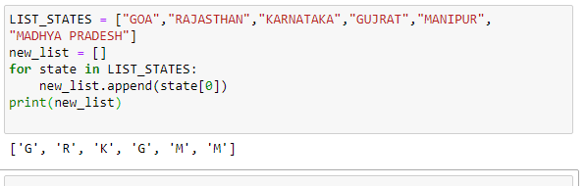

Q. 2. Write a program to replace each string with an integer value in a given list of strings.

The replacement integer value should be a sum of ASCII values of each character of type corresponding string........

LIST: ['Ganga', 'Tapti', 'Kaveri', 'Yamuna', 'Narmada' ]

Ans.

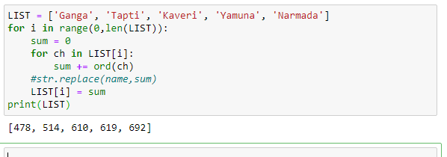

Q. 3. Give a tuple:

tuple = ('a','l','g','o','r','i','t','h','m')

1. Using the concept of slicing, print the whole tuple

2. delete the element at the 3rd Index, print the tuple.

Ans.

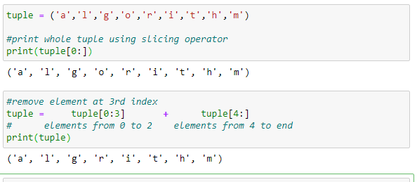

Q. 4. Take a list REGex = [1,2,3,4,5,6,7,8,9,0,77,44,15,33,65,89,12]

- print only those numbers greater than 20

- then print those numbers those are less than 10 or equal to 10

- store these above two list in two different list.

Ans.

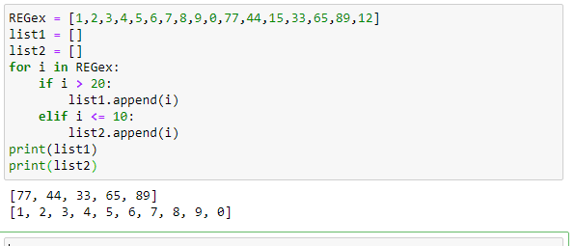

Q. 5. Convert output of datetime.datetime.now() to list format.

Ans. 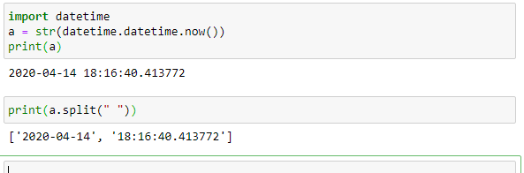

Q. 6. You have to run your Program at 9:00am. Date: 14th April 2020.

HINT:

# You have to use datetime Module or time module..

# You have to convert your output in #LIST_FORMAT

# [ '2020-04-13' , '17:11:01.952975' ]

# you can use this with the help of IF/Else statement

Ans.

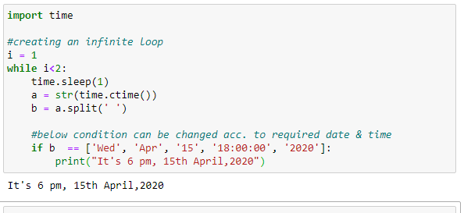

Q. 7. Revise *args and **kwargs concepts.

Ans. *args are used in a function if the number of parameters taken during function call is not known. For this purpose, the formal parameter name is prefixed by an asterisk symbol (*). Below code illustrates the working of *args with different no. of actual parameters:

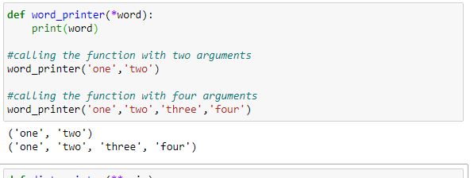

**kwargs are used when keyworded arguments (like key-value pairs in a dictionary) are used and the no. of such arguments used in function call is not known to the programmer. For using this, the formal parameter name is prefixed by two asterisk symbols (**).

